Module 8 Assignment Solutions
The assignment for Module 8 provides practice applying the ERD notation to narrative problem descriptions. You should use the ER Assistant or other drawing tool to complete the problems in module 8. If you want to use the ER Assistant, I encourage you to watch the software demonstration about the ER Assistant, available in module 7.
- Draw an ERD to track lab tests performed by a medical laboratory on clients. The database should track basic client details including a unique client identifier, client name, client insurance provider (if any), client address, client date of birth, and client sex. The database should track the unique identifier for the lab test, the test type identifier, the date and time when the test was administered, and the identifier of the lab employee performing the lab test. A client can request multiple tests in a visit to the lab. The database only contains clients who have had lab tests performed. Each lab test is administered to one client.
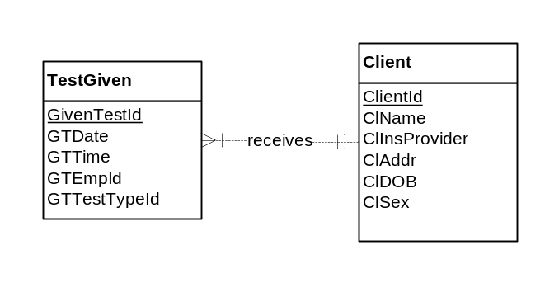
- Revise the ERD from problem 2 with more details about test types. A test type includes a unique test type identifier, a test type name, a test cost, and a test type code. The test administered to a client is associated with one test type. A test type can be administered to multiple clients. A test type can exist in the database without ever being administered.
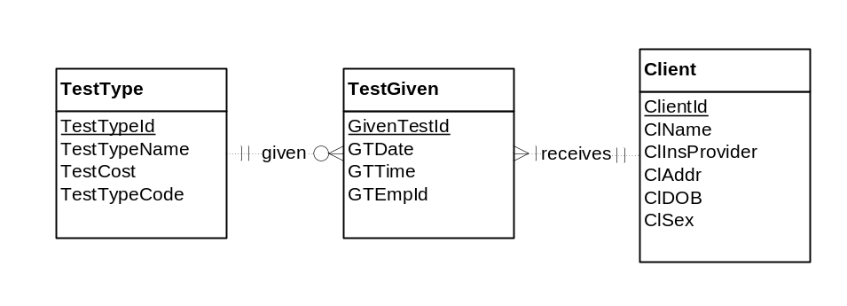
- Revise the ERD from problem 2 with test type items. A test type item includes a unique test item identifier, a test item name, test item unit of measure, and a test item description. A test type includes one or more test items. A test item can be part of one or more test types. Do not use an M-N relationship.
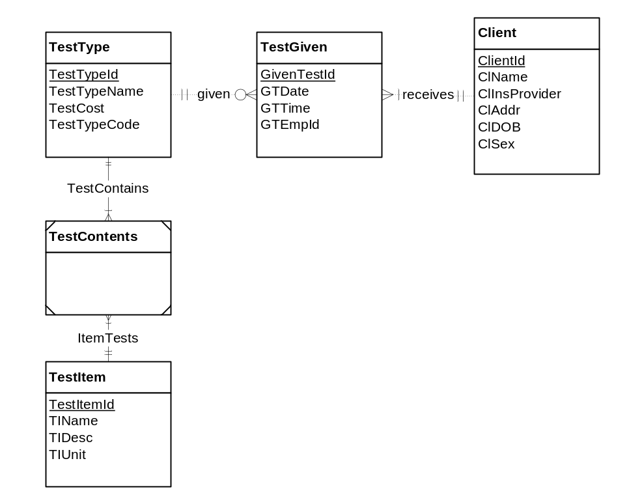
- Revise problem 3 so that an M-N relationship is used.
